Table of Contents

1. What is GitLab? 1

2. Forking 1

2.1 Steps to Fork 1

3. Cloning 2

3.1 Steps to Clone 2

4 Important Git commands 2

4.1 Check files and folder status of the Git repository 2

4.2 Add and Commit files/folders 2

4.3 Commands 3

5 Troubleshooting 3

5.1 SSL Certificate Error 3

5.2 Access denied error 4

# What is GitHub?

GitHub is a software that can be installed in a centralized server to manage code from various developers. For the purpose of learning and collaboration within employees of Cognizant, a separate GitHub instance is available for use. Each employee in company has access to this repository and can login into with network credentials. Each employee can create any no. of projects under his/her profile.

# Forking

Forking, as per Git terminology is to create a child copy of the parent project to work on. This enables the user to work on the requirements individually.

# Steps to Fork

1. In browser, login with you network credentials at [www.github.com](http://www.github.com)
2. Copy and paste the below relevant url in the browser after login.
3. Click fork
4. Click on your name
5. The above steps creates a new project in your profile.
6. If you click on GitHub link on the top left corner, you can find the project listed under your name in the “Your Projects” section. This means that you have successfully completed forking the project.
7. Click on the project.Copy the URL from the browser and have it handy as it will be used during cloning.
8. Go through the folders and files in the project.

# Cloning

Projects that are forked will be available in the Git server, not on the local machine. The process of creating a copy from the server to local PC is called cloning. The steps below will guide to clone the project.

Software version required on the local machine: Git version 2.22

# Steps to Clone

1. Open Windows Explorer and navigate to the required location on the local machine.
2. Right click on the empty space in right hand side of the explorer window and select “Git Bash here” option
3. Execute the following commands. Replace the content in red:

git config --global user.name "<Required Username>"

git config --global user.email "<Appropriate email address>"

git clone <Project URL copied from step 7 during forking>

1. After completion of above steps the project folder would be created with the relevant folders and files in the chosen location in the local machine. The folder structure should be similar to the folders and files in the server.

# Important Git commands

Following are the steps that are used to

# Check files and folder status of the Git repository

This step enable us to know the current status of the files/folders in the code repository. If they are

1. Added
2. Removed
3. File modification
4. Files ready to be committed to Git

# Add and Commit files/folders

Git follows the steps to choose the files to be committed which is termed as “Staging”, followed by “Commit” that saves the code to the local machine Git repository.

If the code changes are complete or if the changes done till then needs to be updated on the Git server, “Push” command can be used to perform the operation.

# Commands

#### Status

git status

#### Add

To stage the added or modified files, use the following command

git add .

#### Status

To display the staged files, the same command to check the status as shown in 3.5.1 can be used.

git status

#### Commit

To save the code to local repository

git commit -m "exception issue fixed"

In the above command, the commit is done with a message giving meaningful information about the change that is getting committed to the local repository. Keyword ‘-m’ represents the message followed by the message specified within the quotes.

#### Push

To transfer the changes from local machine to server

git push origin master

In the above command, the changes committed to the local repository is being PUSHED to the branch “master” in the remote location “origin”

# Troubleshooting

Few common errors that could come up while accessing Git. Listed below are the problems and resolution

# SSL Certificate Error

git config --global http.sslVerify false

# Access denied error

**Steps to be followed to resolve the “Access Denied” error**

1. Open Start Menu
2. Type “credential” and select the application “**Credential Manager**”

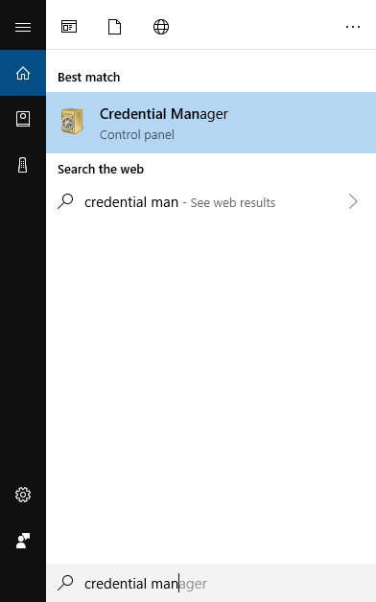

1. In the application, click “**Windows Credentials**”

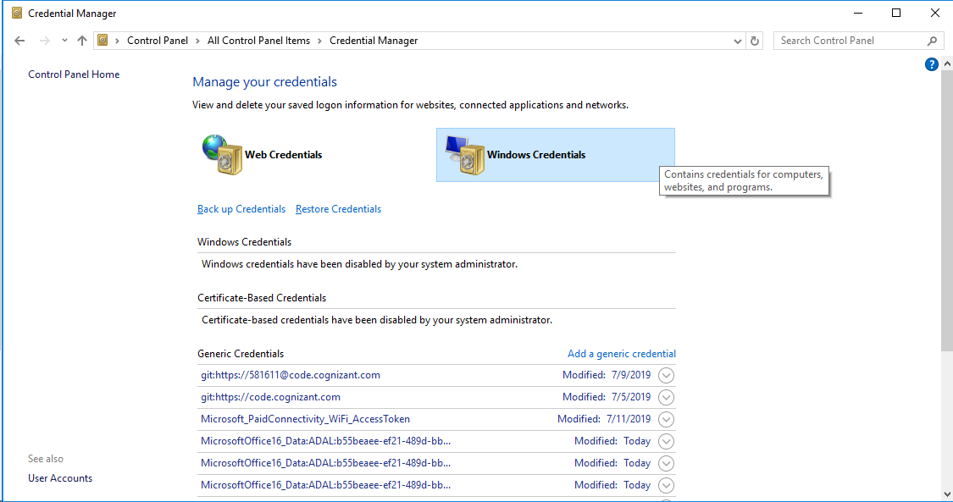

1. Under “**Generic Credentials**” section click on “**git:https://code.cognizant.com**”

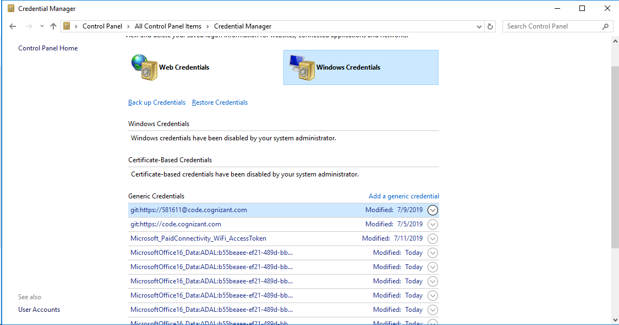

1. Click “**Edit**”

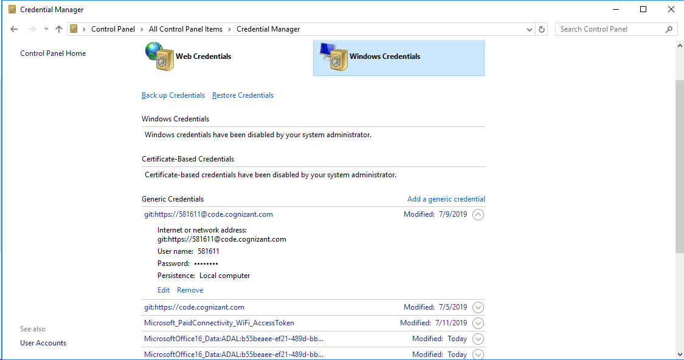

1. In the new window key in the current password and click “**Save**”

Now execute the git command in Git Bash and check if the command succeeds.